Multiple-choice section – choose the correct answer

Question 1 [2.3]

The hypotenuse of a right-angled triangle has a length of 11 cm. One of the shorter sides has a length of 7 cm. What is the value of the third side?

A  cm B  cm C 170 cm D  cm

Question 2 [2.1]

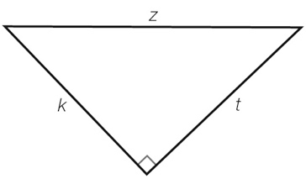

Which of the following statements is true?

A *z*2 + *t*2 = *k*2 B = *z* C  D *z*2 – *k*2 = *t*2

Question 3 [2.5]

If *a* = 14 and *b* = 48, and *a*, *b* and *c* form a Pythagorean triple, what is the value of *c*?

A 47 B 48 C 49 D 50

Question 4 [2.2]

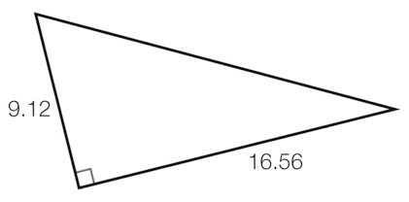

Calculate the length of the hypotenuse, to 2 decimal places.

A 24.68 B 13.82 C 18.91 D 18.90

Question 5 [2.4]

A yacht has a right-angled triangular sail that is 2.3 m in height and 1.6 m along the base. The right angle connects the base with the height. What is the length of the third side of the sail, to 1 decimal place?

A 1.7 m B 2.2 m C 2.4 m D 2.8 m

Question 6 [2.2]

What is the perimeter of this shape, correct to 2 decimal places?

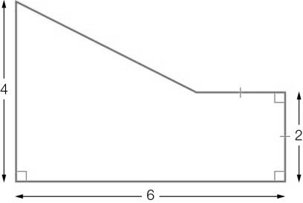

A 18.32 B 18.47 C 20.32 D 21.21

Question 7 [2.4]

Mia runs 200 m due north and then 300 m due east. She then walks in a straight line back to her starting point. What is the difference between the distance she runs and the distance she walks?

A 361 m B 276 m C 139 m D 100 m

Question 8 [2.5]

Which two triangles have the same area? Use your knowledge of Pythagorean triples to find missing shorter sides where necessary. (The triangles are not drawn to scale.)

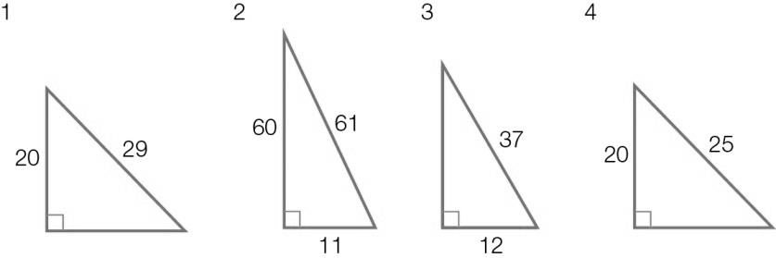

A 1 and 2 B 1 and 3 C 3 and 4 D 2 and 4

Multiple-choice results: ___ / 8

Short answer section

Question 9 1 mark [2.1, 2.2]

Use words from the list below to complete the following sentences.

hypotenuse converse Pythagoras’ theorem rational approximation proof surd irrational

Many square roots are _________________ numbers. Written as rounded decimals, they are _________________. To write an exact value, it must be written in _________________ form.

Question 10 4 marks [2.1]

Which of the following triangles contains a right angle? Use the converse of Pythagoras’ theorem to justify your answer.

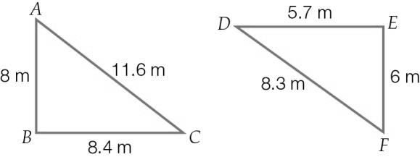

Question 11 2 marks [2.2]

Find the value of k in the following diagram, to 1 decimal place.

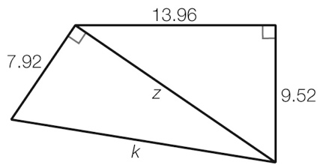

Question 12 2 marks [2.2]

Find the exact value of *w*.

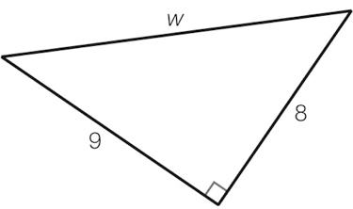

Question 13 3 marks [2.2]

Calculate the difference between the lengths of the two hypotenuses in the following diagram, to 2 decimal places.

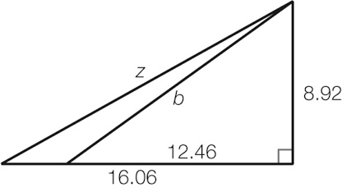

Question 14 3 marks [2.3]

Find the value of the pronumeral in the following right-angled triangle, to 2 decimal places.

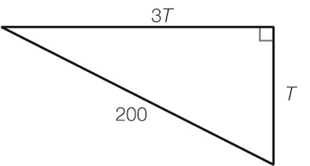

Question 15 2 marks [2.3]

Find the exact value of the unknown side in this right-angled triangle.

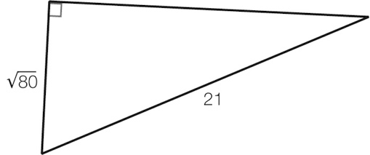

Question 16 2 marks [2.3]

Find the value of *u* in the following diagram, to 2 decimal places.

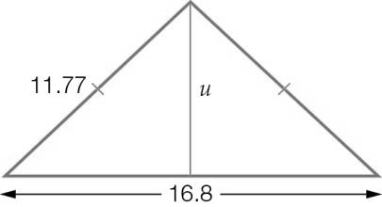

Question 17 3 marks [2.4]

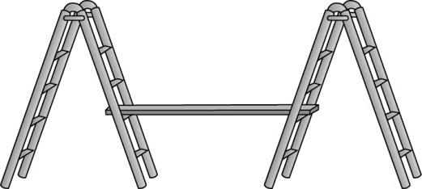

A painter sets up the trestles and plank as shown, so that the horizontal plank is 1.5 m above the ground. The plank rests on the second step, which is exactly halfway up the 3.5-metre-long trestle. If the inside feet of the trestle are 2 metres apart, what length of plank is there between the two trestles, to the nearest cm?

Question 18 3 marks [2.4]

A mould for a plastic wedge is constructed in the shape of a triangular prism as shown. Its base length is 8 cm and its base width is 4 cm. The right-angled triangular side has a hypotenuse of 13 cm.

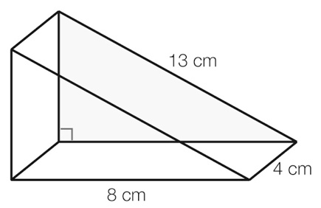

(a) What is the height of the mould? Give your answer in exact (surd) form.

(b) Calculate the volume of liquid plastic that can be poured into the mould, to the nearest cubic centimetre.

Question 19 2 marks [2.2]

The hypotenuse of an isosceles right-angled triangle is *x* metres long. How much longer is the hypotenuse of the triangle if the shorter side lengths are increased by 3 metres?

Question 20 2 marks [2.5]

Replace the pronumeral with a positive integer to form a Pythagorean triple.

(a) {33, 56, *v*}

(b) {36, *j*, 85}

Question 21 2 marks [2.5]

Using Pythagoras’ theorem, determine whether or not the following sets of numbers could be classified as Pythagorean triples.

(a) {20, 48, 52}

(b) {63, 72, 97}

Question 22 2 marks [2.5]

Quany has a piece of string 40 cm long and wants to make a right-angled triangle. What whole-number side lengths use all of the string?

Short answer results: ___ / 33

Extended answer section

Question 23 5 marks [2.1, 2.5]

Jasper is building a kennel and wants to check that his plan for the floor is ‘square’. He measures the length of the floor as 1 m, the width as 1.3 m, and the diagonal across the floor as 1.7 m.

(a) Sketch a diagram (scale is not important) to represent the plan of the kennel floor in question.

(b) Use the converse of Pythagoras’ theorem to show that Jasper’s kennel floor is not ‘square’.

(c) Suggest how Jasper can adjust the length and/or the width of the kennel floor to ensure that they meet at right angles. Use mathematics to explain how your answer will ensure that the kennel is ‘square’.

Question 24 9 marks [2.2, 2.4]

Houda walks from the ice-cream shop (point A) to her school (point B). She walks 50 m west, 25 m north and then 100 m west.

Jose walks from his school (point B) to the video games shop (point C). To do this, he walks 300 m south, 80 m east and then 150 m south.

(a) Draw a diagram (scale is not important) to represent the journeys of Houda and Jose.

(b) Calculate the total distance walked by Houda. Calculate the total distance walked by Jose. Who walked further and by what distance?

(c) If a straight line is drawn from point A to point B, what is the length of this line?

(d) If a straight line is drawn from point C to point B, what is the length of this line?

(e) Use your previous two answers to determine which shop (ice-cream or video games) is closer to school and how much closer it is.

Question 25 9 marks [2.3, 2.4]

Giuseppe is designing a new wooden gate as shown. The diagonals will be constructed using wire.

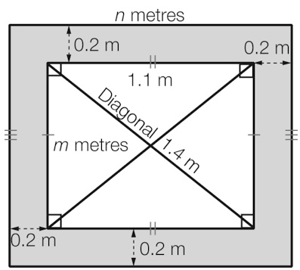

(a) Calculate the value of *m*, to the nearest millimetre.

(b) Calculate the value of *n*.

(c) Calculate the total area of wood needed for the gate, to 2 decimal places.

(d) If wood costs $11.20 per square metre and Giuseppe decides to buy an extra 10% of wood to allow for mistakes, determine the total amount of money Giuseppe will spend on wood.

Extended answer results: ___ / 23

TOTAL test results: ___ / 64